Checking Noise Masking with XL2 Spectral Limits

Introduction
There are many applications for sound masking systems:
- Open plan offices are gaining in popularity
- Speech privacy in medical offices under the Health Insurance Portability and Accountability Act (HIPPA)
- A better night’s sleep in a hotel by masking out noises from other guests or hotel operations
The installed space is part of the sound masking system. Each installation has a unique floor plan; absorption of floor, walls and ceiling; and limited locations to install sound masking speakers.
Good practice is to verify operation of a sound masking system. Typically, the manufacturer of the system specifies the spectrum of the masking noise. The masking noise spectrum varies from location to location as a function of distance from speakers and the characteristics of the immediate space (e.g. in a hotel room, the bathroom is highly reflective while the sleeping area is absorptive)
The NTi Audio XL2 Audio Analyzer with the Spectral Limits Option is a powerful, handheld system for checking and documenting the installed performance of sound masking systems.
This document steps you through creating a limits or masks for testing sound masking system. At the end it references locations of additional information like pages in the XL2 User Manual and other instructions.

Defining Limits
If you already have a tolerance file, you can skip ahead to “editing the limit file on the PC” section.
If you do not have a tolerance file to work from, it is easiest to create one on the XL2.
Open either the 1/12 Oct + Tol (for 1/1-, 1/3-octave, 1/6-, or 1/12-octave limits) of FFT + Tol (for narrow-band FFT limits. This document will use 1/3-octave band limits.
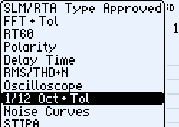
Configure the XL2 for the resolution of the desire mask/limits (e.g. 1/3-octave) and any broadband limits (e.g. A and Z)

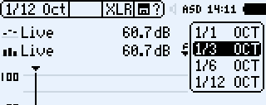 | 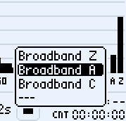

Start and stop a measurement
Capture EQ to C1
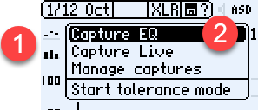 | 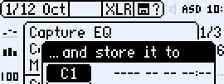
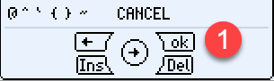

Start Tolerance Mode, using C1

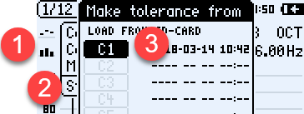

Define if the Tolerance mode will be high/low, high or low. Then save to SD-Card
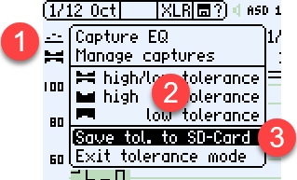 | 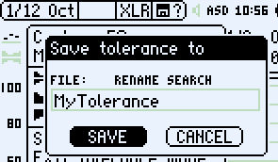

Connect the XL2 to a PC as USB Mass Storage

Editing the Limits File on a PC
Open the Tolerance text file (Tolerances directory on XL2) using Excel.
UNDEF is used when you do not want to enter a value. To not test a broad band value, put UNDEF for Min, Ideal, Max (e.g. Z Tolerance below). Later you can edit the tolerance file with a numeric limits for the Min or Max Z-weighted broadband value.

For BandTolerances frequency masks, here is some guidance:
- Frequencies have to be listed in ascending order
- It is not necessary to have limits for intermediate frequencies between two defined frequencies (e.g. 125, 160, 200, 250 and 315 Hz will have the same limits defined for 100 and 400 Hz)
- To stop the limit line, put UNDEF for Min, Ideal, and Max at a frequency (e.g. 400 Hz below). Note that having UNDEF at the same frequency as a defined limit will override the limit.
- To create a step, have the same frequency value on two successive lines (e.g. 2000 Hz below)
Additional functionality like LevelOffset (define a mask relative to a background noise level), SumBands(sum bands over a range of frequency, equivalent to testing through a high-, low- or band-pass filter) are described starting on page 158 of XL2 Manual

#Unit
dB
#Mode
HighLow
#Columns
Frequency | Min | Ideal | Max
#ATolerances
UNDEF | 20 | UNDEF | 80
#ZTolerances
UNDEF | UNDEF | UNDEF | UNDEF
#BandTolerances
100 | 20 | UNDEF | 60
400 | 20 | UNDEF | 60
400 | UNDEF | UNDEF | UNDEF
800 | 30 | UNDEF | 70
2000 | 30 | UNDEF | 70
2000 | 40 | UNDEF | 60
8000 | 40 | UNDEF | 60
Save as text file from Excel
Copy the file to the Tolerances directory on the XL2

Loading the Limits on the XL2
Start the XL2 in normal mode.
Exit Tolerance mode if XL2 is showing tolerances
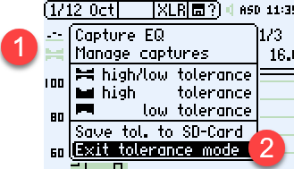
Start Tolerance mode
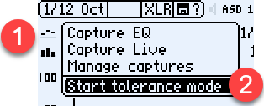
Load from SD-Card
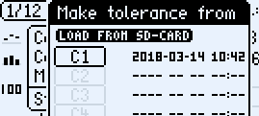 | 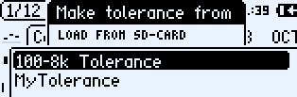

Configuring XL2 for point measurements
Set the reading to EQ or Min (A) and adjust the Range (B) to the expected level.
Press the Start/Stop to start the measurement and again to stop it (alternatively, you can configure the XL2 to run for a preset measurement time (C).
The results bar (D) will either say PASSED or indicate which frequencies are outside the limits. The “limit” LED on the XL2 will indicate overall pass or fail.
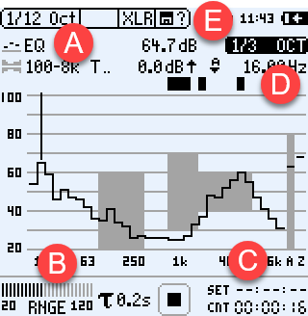
Save the measurement (E) if documentation of each measurement is need. See “How to use savename to make testing easier on NTI XL2” for a method to pre-define measurement names.

Configuring XL2 to survey or “walk” a space
Set the reading to Live (A) and adjust the Range (B) to the expected level.
The measurement and limit testing is now running continuously (no need to start or stop the measurement)
Adjust the exponential averaging time (C) to get more or less averaging.
The results bar (D) will continiously say PASSED or indicate which frequencies are outside the limits. The “limit” LED on the XL2 will indicate overall pass or fail.
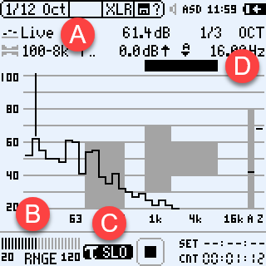
In Live mode, the measurement data is always current. There is no way to save and document the results.
To document the results of a space survey either set (A) to Min or Max, start and stop the measurement and then save the results.

Additional References
XL2 User Manual
- Spectral Limits Option (Capture + Tolerances), page 148
- 1/12 Octave + Tolerance (optional), page 96
“How to use savename to make testing easier on NTI XL2” instructions
Video on using the Spectral Limits Option for vibration testing http://www.nti-audio.com/en/support/video-tutorials/videos-for-xl2-analyzer.aspx#XL2-Spectral-Limits

